To: Nicolas Dei Castelli, ADB
Wagner Colombini Martins, Team Lead, Logit
Livia Delgado, Logit
Nikolos Archavadze, STS
Zurab Beradze, STS
Re: Output 8: Parking Survey Report and Data; and Output 10: Parking Policy
Date: October 7, 2026
The overall comments on 09/30/2026 versions of Output 8 and Output 10 are included in the attached updated Consolidated Comments and Deliverables 10062026, under worksheet T3. A few items will be easier to understand with visual backup, so this memo can also be used for finalizing the documents.
Overall, both documents are much better. They provide a good foundation upon which the Municipality can make rational parking policy decisions, and it arms the municipality with the data needed for them to constructively engage affected communities.
All of the previously raised issues have now been resolved unless mentioned in this memo.
The following remaining outstanding issues were observed:
- Output 8’s Executive Summary is a couple of cursory sentences that belong more in an introduction. There should be a proper executive summary, as there was in the last version. Output 10 has no executive summary, and there should be one, as there was in the last version.
- For the most part the ‘retained on-street parking’ data and mapping has been updated with v2 of the conceptual designs. It is reasonable to cap the update on the v.2. conceptual design. An appropriate caveat, that it is subject to change with later iterations of the conceptual design, has been added. I did notice, however, one location where some v2 on street parking retained is missing:
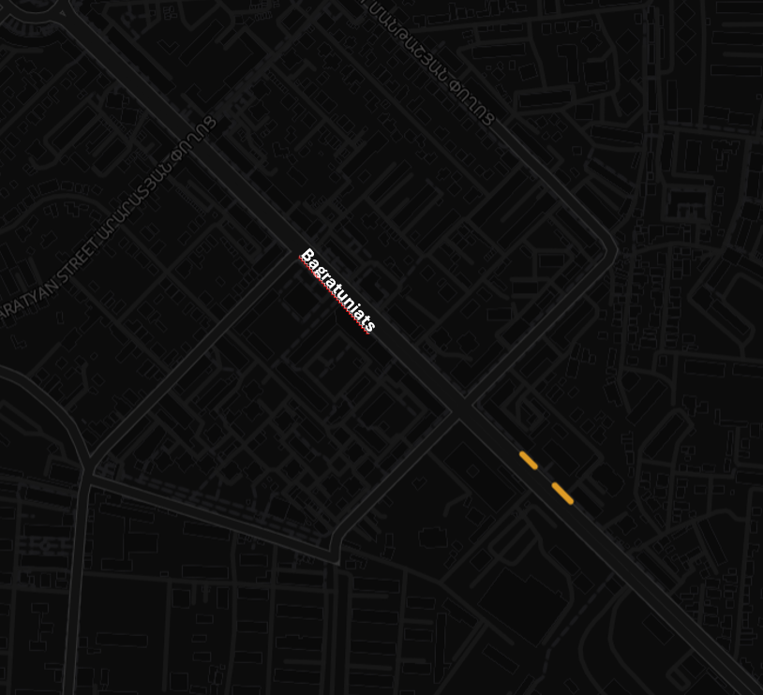
Figure 1. This section of Bagratuniats on Corridor 1 shows only two small lots of curbside parking retained. The conceptual design shows more.
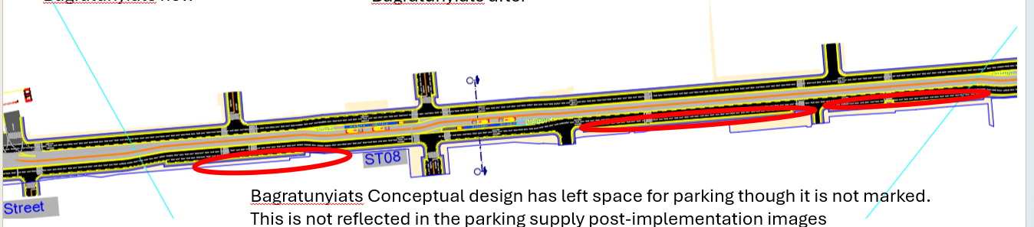

- Figure 16 on p. 20 is great. This is what I was looking for. However, I think there is an error in the results for Gai Avenue, and it makes me question what exactly this data means.
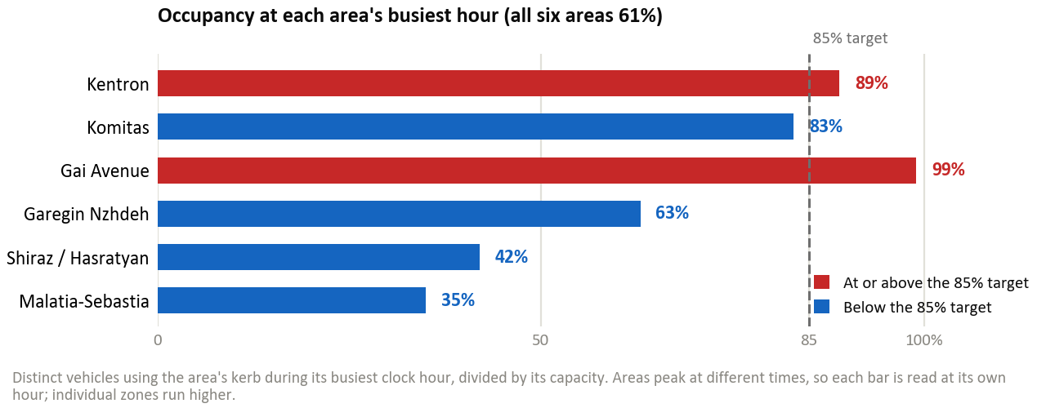
When the detailed occupancy levels along Gai Avenue are shown, most of the occupancy levels are well below 85% occupancy. The reason given for the high parking demand is the Mega Mall, but the congested area is not near the Mega Mall.
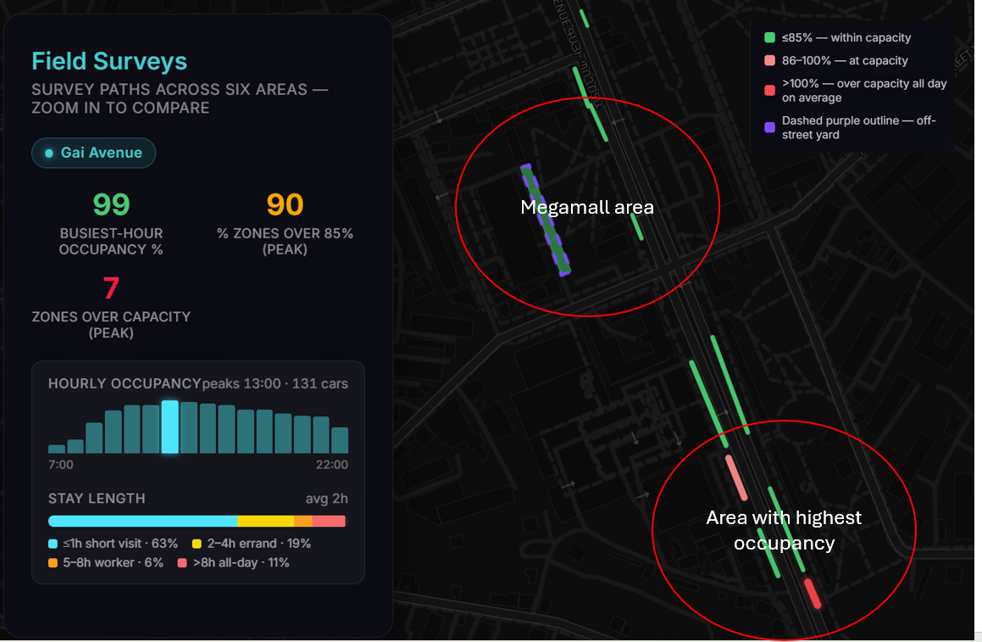
The legend indicates that most of the zone is below 85% occupancy, with only two small areas above 85%. The summary data, however, says the peak hour occupancy is 99%, and that 90% of the zones are over 85% capacity, but this is clearly now what the map is showing. The table also references zones at greater than 100% occupancy, which is also in my view a problem that is discussed next.
- Remaining confusion over how the occupancy rate was calculated and whether the occupancy rate can be over 100%
There remains confusion in the document about how the occupancy rate was calculated. In my last set of comments dating 08/13/2026 I pointed out why the maximum occupancy should be 100%, and I provided a methodology for deriving a max 100% occupancy using the data set that you collected. When I look at Figure 16 on p. 20, I believed that the latest version had corrected this problem, as the figures never rise above 100%, and with the exception of Gai Avenue, which I believe is an error, they look about like what they would expect for the peak period.
In Output 8, Section 6.1., there are now two different explanations of how occupancy is calculated. In 6.1. par 3, it reads "Occupancy is the share of parking spaces in use. It is calculated as the number of vehicles observed on a street segment divided by the number of vehicles that segment can hold (i.e., its capacity)." This is correct.
In Output 10, p.15, Section 3.5, par. 2, it says the following: “The target occupancy for on-street parking is generally considered to be 85%. At this level, the street is being utilized effectively, but there is still a 15% vacancy rate-meaning one in every seven spaces is empty. This ensures that an arriving driver can find a spot without "cruising," which is a major contributor to urban congestion and emissions.” This is also correct.
What is unclear is how we get a proxy measurement for this concept of ‘occupancy’.

In Output 8, Section 6.1, in Par. 5, it says "a zone can read above 100%. The count covers every vehicle that used the kerb during the hour, not how many stood there at one moment, so three cars using one space in turn read as 300%; the busiest zone in the survey reaches six times its capacity. An area could do the same, although none does: the highest is Gai Avenue at 99%."
This measurement does not well capture the concept of occupancy. As was explained in a previous memo, if you are taking the total discrete vehicles parked in a zone over the peak hour, and divide this figure by the total number of vehicles, this will not tell you "the share of parking spaces in use" because the turnover rate could be very high. If every vehicle only stays for 5 minutes, the curb could be mostly empty, implying a very low occupancy rate.
I provided a methodology to calculate the occupancy from the data you have. In the memo I sent dated 08/12/2026, I said the following:
“I was able to get a result of a maximum of 100% by giving each discrete license plate a 0.5 hour parking time for the hour when the vehicle is first observed and the hour when the vehicle is last observed, assuming that on average the vehicle will be parked ½ hour during its first and last hour. I don’t know how much additional data analysis this would require and leave it up to Nico whether or not he wants the occupancy rates recalculated to represent a maximum of 100%. I did it manually which was a lot of work but there is probably a much faster way to do this using some light programming.”
I realize that this doesn’t fully explain my proposed methodology.
When I saw your occupancy figures all fall under 100% and readjusted downward to levels much closer to what was expecting to see, I figured you had done something like what I expected, but given the above information I am not so sure.
Using your methodology, the July Version of Output 8 (p.18, Section 7, first paragraph) the following table was provided. The occupancy rate in Kentron, for example, is 138%.
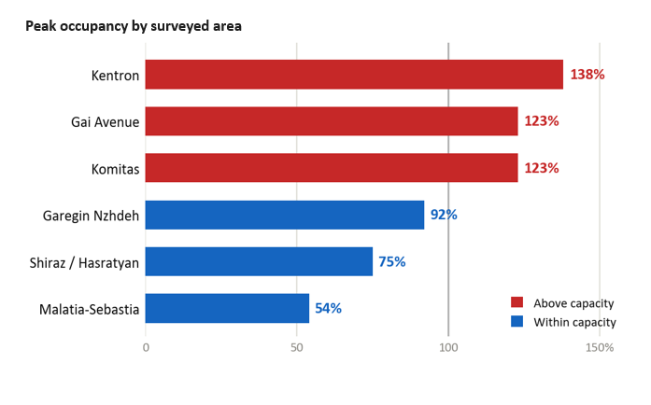
In the new version, the occupancy rate in Kentron has dropped down to a more reasonable 89%. If, as you explain in Section 6.1. Par 5 quoted above, that is the methodology that you used, then the 89% only looks like the expected result somewhat coincidentally, then that is a problem. What explains the sudden drop from 138% to 89%? If, on the other hand, you used some other methodology to calculate the 89%, what was it? It is never explained. As a lot of your analysis rests on this data it is imperative that the data is accurately processed and we understand what it means.
When you go over the calculation of off-street capacity, we are again seeing figures that look like the old numbers and the old methodology, with results well over 100%.
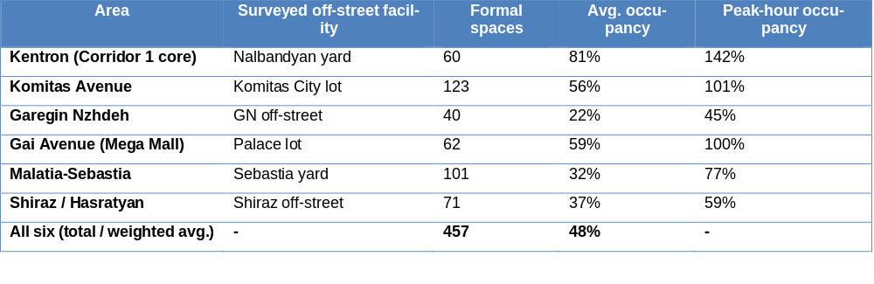
These figures now no longer seem consistent with the much lower on-street occupancy figures quoted in the September report. Are you using the same methodology for both calculations?
On page 20 of Output 8, referring to the off-street parking occupancy, the text reads as follows:
“At the peak hour, however, three of the six are already at or beyond capacity (Nalbandyan 142%, Komitas City 101%, Palace 100%) and only three keep meaningful spare (Garegin 45%, Shiraz 59%, Sebastia 77%). Each of these is a single facility measured at its own busiest hour, and a reading above 100% is a real measure of overflow rather than a data error; the chapter on the field occupancy survey sets out in detail how it arises.”
The chapter on field occupancy survey mentioned above refers back to the two paragraphs already quoted.
It is not intuitively clear to me what a 142% occupancy rate would look like for an off-street lot. Would this have 42% of the total capacity of the facility waiting in line out the door to enter the garage?
- An alternative methodology for calculating the occupancy rate with your data set.
As I didn’t explain very well my proposed methodology for calculating the occupancy rate, I’ve explained it in more detail here. In the below table, taken from your zone-level data for Zone 40, the Y axis is all of the separate identified vehicles that parked in Zone 40 over the course of the survey period. There were 80 discrete vehicles that parked in the zone over the course of the survey period. At any one given time there were as many as 27 discrete vehicles parked in that zone over the course of the peak hour which appears to be between 5 and 7 pm. There are only 23 parking slots in Zone 40. Therefore, by your calculation, the occupancy rate is 117% for that one zone. This might be aggregated for all the zones and end up with an occupancy rate over 100%. This creates the image that there are vehicles double parked all over the place, which is not the case.

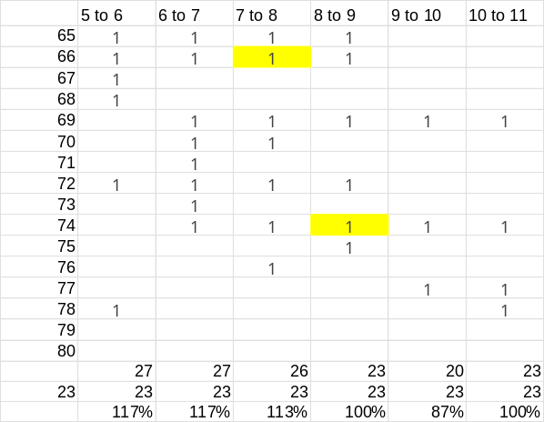
Figure 2. Occupancy calculated as described in Methodology
The occupancy rate is intended to give us a snapshot of the likely number of empty parking spaces we are going to find along the curb were we trying to find a parking space during the peak hour. This figure does not tell us the answer to this question because we don’t know how long each vehicle is parked in each spot.
To be accurate, the fraction of the hour that the car was parked in the spot should be recorded in each cell. Since we don’t have this exact information, we only have hourly counts, we can only create a proxy for the amount of time they parked by attributing a half hour to the first hour the vehicle appears in the zone, a half hour for the last hour the vehicle appears, and a full hour for any intermediate hour.
At least in this sample, using this method, we end up with an occupancy rate that reaches 100% but never surpasses it, as shown below. Interestingly, it changes somewhat the peak hour.
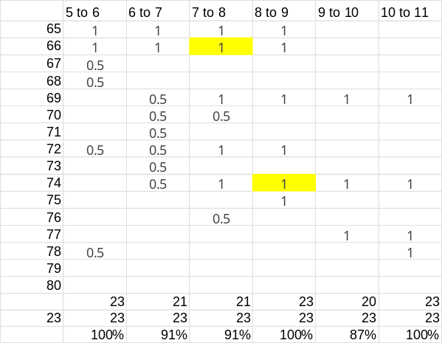
ndeed, generating this analysis was laborious for me, but it is probable that the analysis could be done rather quickly by someone with programming experience or even using AI.

